**EDIT**

click on indexes

- **Create Index**: this is classical and usual way

- **Create Extension Index**: it’s same function with ‘Create index’, but this kind of index will not be overwritten in SAP upgrade.

note: When doing SAP upgrade, there is a possibility to delete or overwrite the current secondary index customer created for performance issue. This issue might make a critical performance issue. Even though we found the root cause, it would take very long time to create index in production server because index is small copy of table.

When creating index, ‘Extension Index’ protect this risk in advance

click on indexes

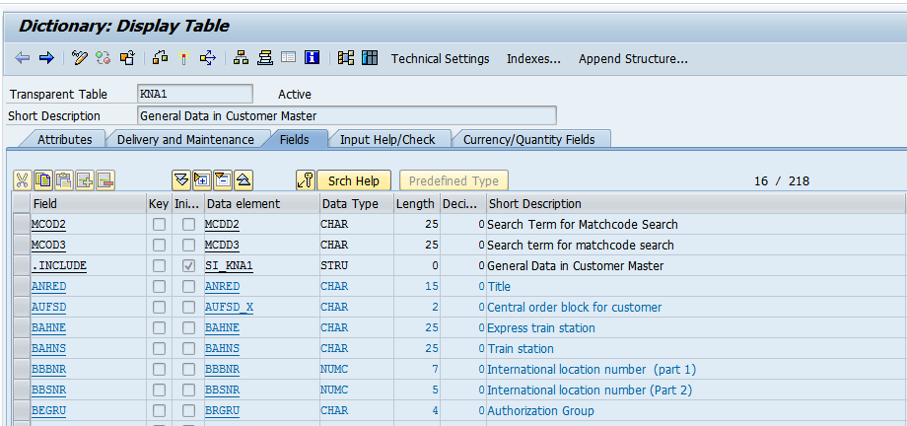

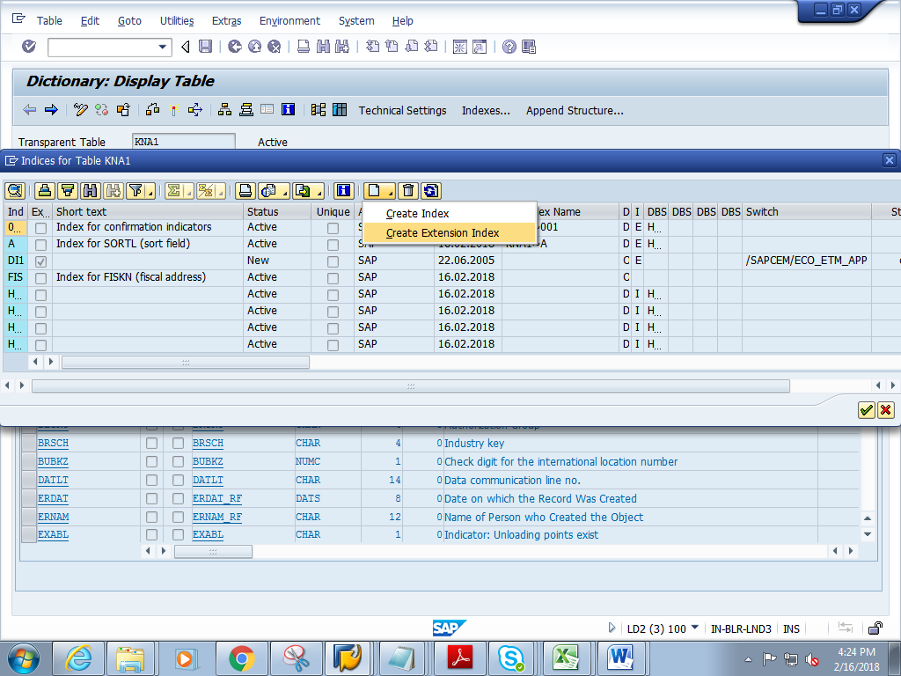

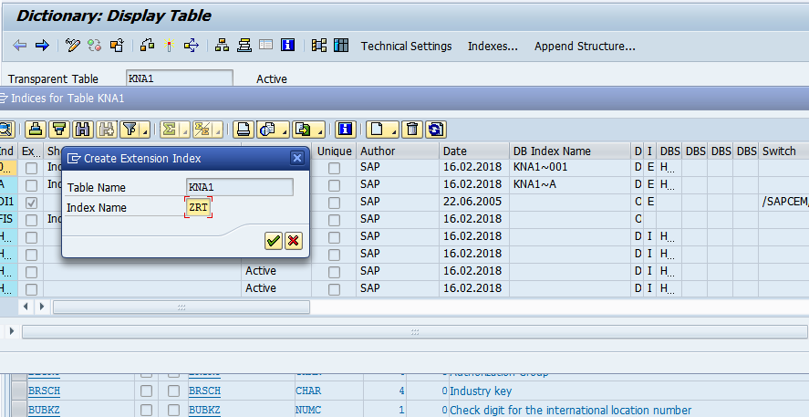

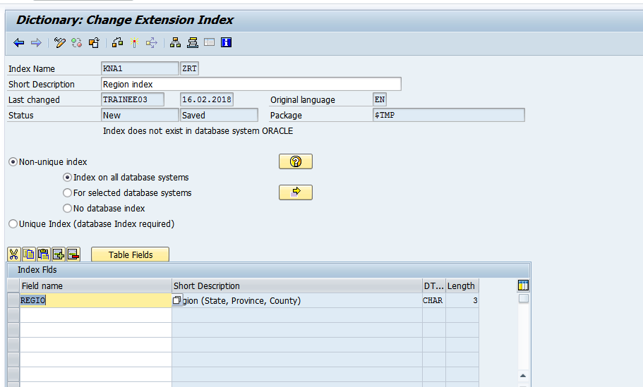You will find your extension index created ZRT

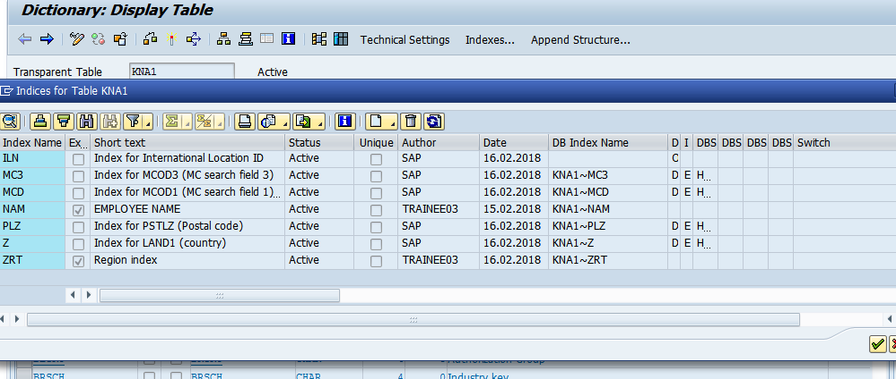

Select it and click on continue (to edit the index by adding more fields)

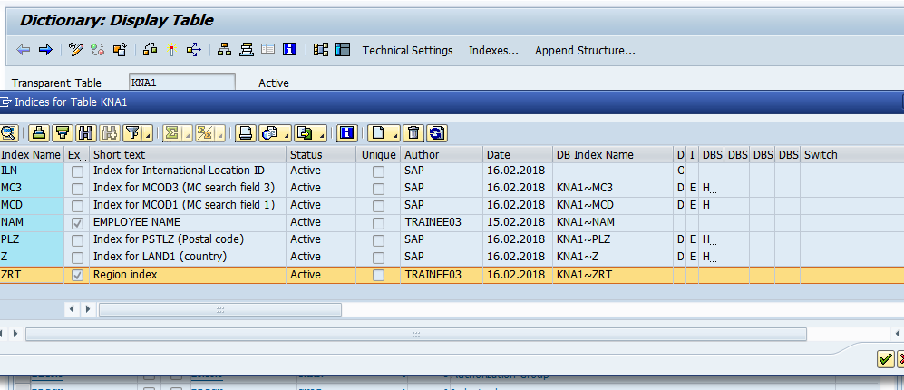Add one more field

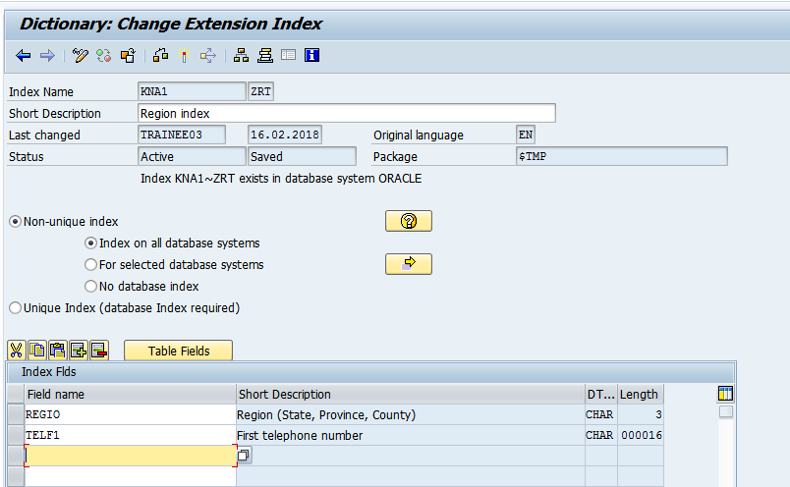save and activate

Check that new fields are added to your index.

